Neural Networks

Atul Vidyarthi (S20170010016)

D.Naga Pranav (S20170010038)

1. Neural networks process information in a similar way the human brain does. The network is composed of a large number of highly interconnected processing elements(neurones) working in parallel to solve a specific problem.
2. Neural networks learn by example. They cannot be programmed to perform a specific task.
3. There are multiple layers in a neural network. The first layer is the input layer and the last one is the output layer.
4. The more the number of layers, the better is the accuracy. Also, the more the number of layers the slower is to train the network.
5. The number of neurons in the hidden layer may or may not increase the accuracy of the network. It depends on the complexity of the problem. And increasing the number of neuron more than what is required, decreases the accuracy.
6. There are two steps in training the neural networks - Forward propagation and backward propagation. In forward propagation, we take the weighted sum of the inputs, pass it through the activation function and store it in the neurons of the hidden layer. Now we do the same to find the values of the neurons in the consecutive hidden layers and the final output layers. The number of neurons in the output layers is same as the number of classes, the dataset is based on.
7. In backward propagation, we find the gradient from the loss functions and updated the weights as per the following equation:

$w_{new} = w_{old} +eta. del(J)$

1. We have different loss function. But we have used two of them namely the sum of squared deviation and the cross entropy. Generally Cross Entropy performs better than the sum of Squared Deviation.

Sum of squared deviation Loss Function:

$J = 1/2 * \sum_{r}{}(t_{r}-{z_{r}}_{}){}^{2}$

Cross Entropy Loss Function:

$J = \sum_{{}_{}r}{} t_{r} log {q_{r}}_{}$

Graphs

Cross-Entropy:

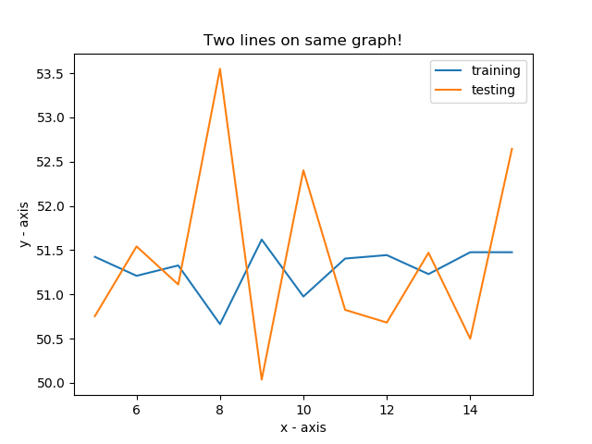

Sum of squared deviation:

